COLTON HILLS COMMUNITY SCHOOL
Sixth Form Application

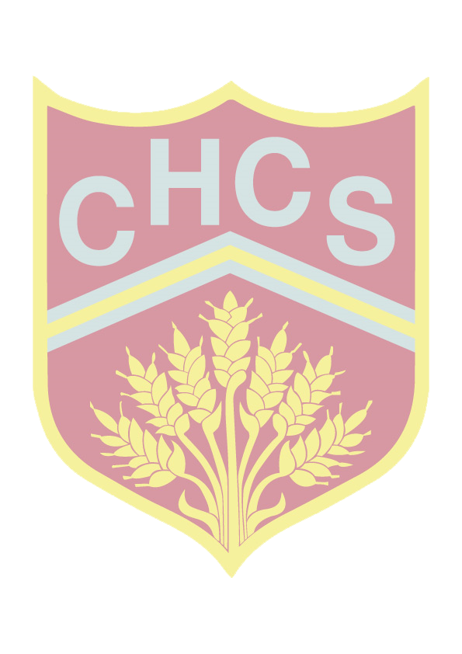
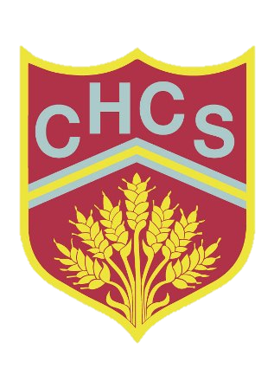

At Colton Hills Community School we offer fully inclusive Post 16 education with a range of learning programmes that will suit a wide variety of career pathways.

If you are interested in joining our Sixth form, please complete the application form and return it to:

Colton Hills Community School, Jeremy Road, Wolverhampton, WV4 5DG
Or email the application through to: coltonhillsschool@wolverhampton.gov.uk

If you would like to talk to someone or require further information please contact Mr Gittins - Sixth Form Leader or Mr Ryan – Assistant Sixth Form Leader on 01902 558420.

Personal Information
Surname | First Name
Other names

DOB | Nationality
Address

Post Code
Your mobile number | Your email address

Parental Information
Parent or Carer’s Names

Address

Post Code
Home phone number | Mobile Number

Education History
Current School

Dates Attended

GCSE Examinations (to be completed by external applicants only)
List the examinations you have already taken and examinations to be taken next summer
Date of Exam | Board | Subject | Level | Predicted Grade | Result

Academic Reference to be completed by your Head of Year or Senior Teacher

Have you applied to any other institution? Yes / No

Name of Institution

Reason for application

List the subjects you are interested in studying in the Sixth Form at Colton Hills Community School
Refer to the Sixth form Option Booklet/Prospectus for detailed entrance requirements for all courses.

What are your career aspirations?

Write a short statement outlining why you want to join the Sixth Form at Colton Hills Community School, what qualities you will bring and how you might contribute to the school. You can also add any positions of responsibility that you have held. (Continue on a separate sheet if necessary)

We encourage young people to developing their Life Skills and contribute to the school and wider community. Please tick the areas that you would like to be involved with.

 |  | Sixth Form Committees |  |  |  | Parent Evenings and Events
 |  | Community Events |  |  |  | Other (please specify)

Signed Applicant Date
Signed Parent or Carer Date
Sixth Form Curriculum Offer 2017 - 2018
BTECS:
Those wishing to take a double qualification must choose that subject in both blocks where it is listed.

Maths and English resit:
Any students accepted into the sixth form who do not have a C grade in GCSE Maths or English, must continue to take those subjects until they have secured a C grade. This is a condition of being accepted into our sixth form.

PHSE:
All students in years 12 will be take part in PSHE days which will be spread out throughout the year.

Mentoring:
In year 12 students will complete a mentoring course which will enable them to take a mentoring role for two hours per week. Mentoring will be allocated dependent on interests and skills. All sixth formers are expected to support younger students with reading and literacy skills as part of the mentoring role.

Results:
Please ensure that your GCSE results are returned to the school no later than Monday the 4th of September in order for us to process your application and submit any and all offers.

Please refer to the Sixth form Option Booklet for detailed entrance requirements for all courses.
All students will be expected to attend the Sixth Form induction programme at the end of June. If you are unable to attend, please inform Mr Ryan as soon as possible.

You can find out further information about our curriculum offer from J. Lockley - Deputy Head teacher or from Mr D Gittins – Sixth Form Leader.

